Tasks on Ansible – 01
1) Watch ansible-01 video and write down notes.

Completed Watching video and notes prepared.

2) Setup one master and two worker nodes in ansible.

First, we need to create 3 instances one as Ansible controller and another two as workers on ubuntu 24.04.

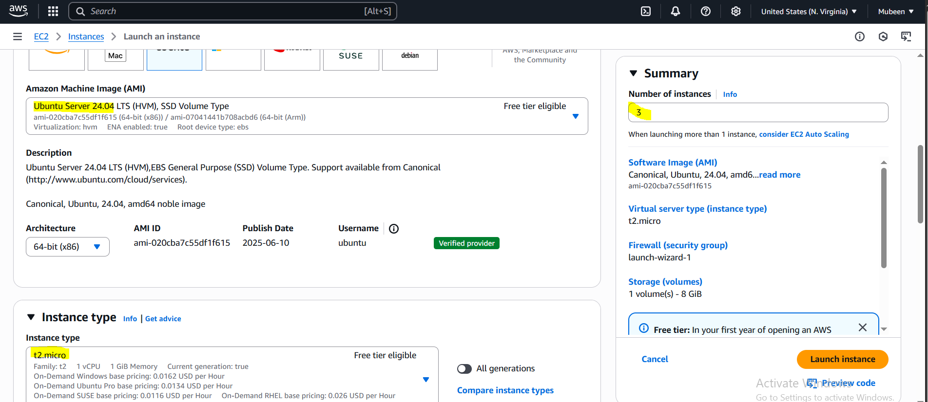

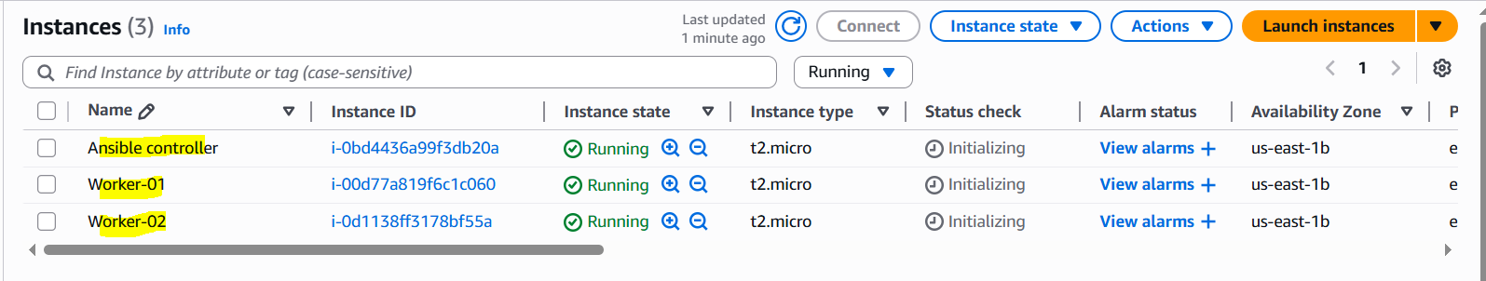

Login to the Ansible controller install and setup the Ansible.

Prerequisite for Ansible is python and python is by default available in AWS Servers. So verify the version with python3 --version.

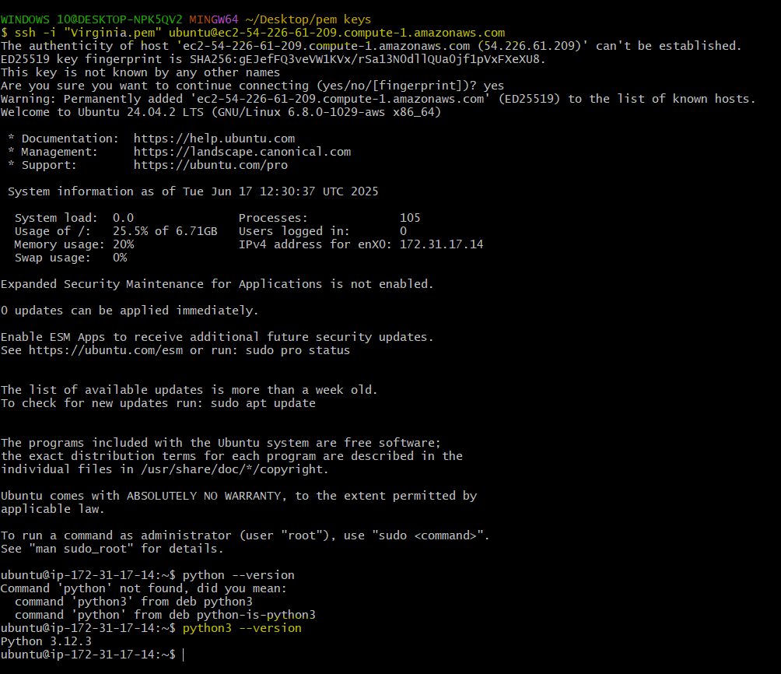

Make sure to use same user for all the servers currently I’m using root user.
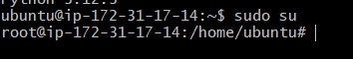

Install Ansible in the Ansible controller server:

Step 1: Update Your System (compulsory for new server)
sudo apt update -y
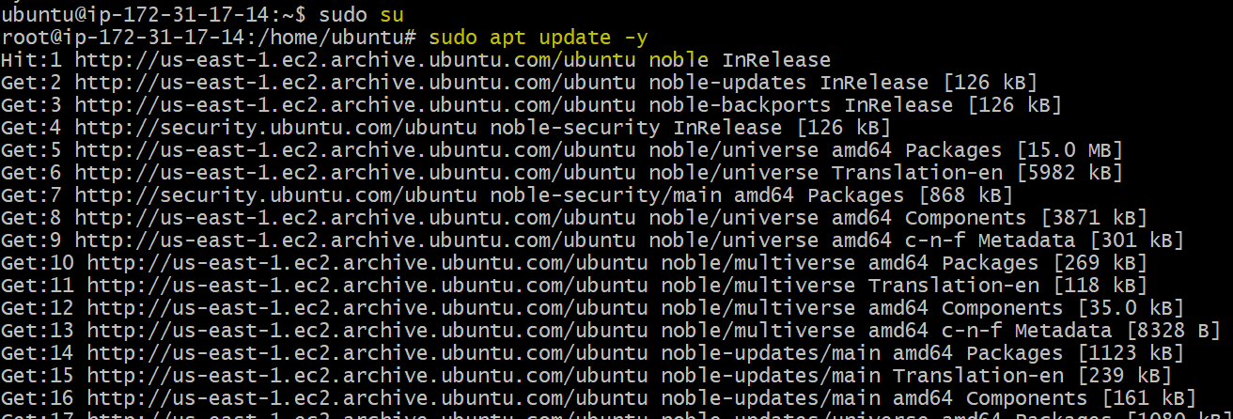

sudo apt upgrade -y
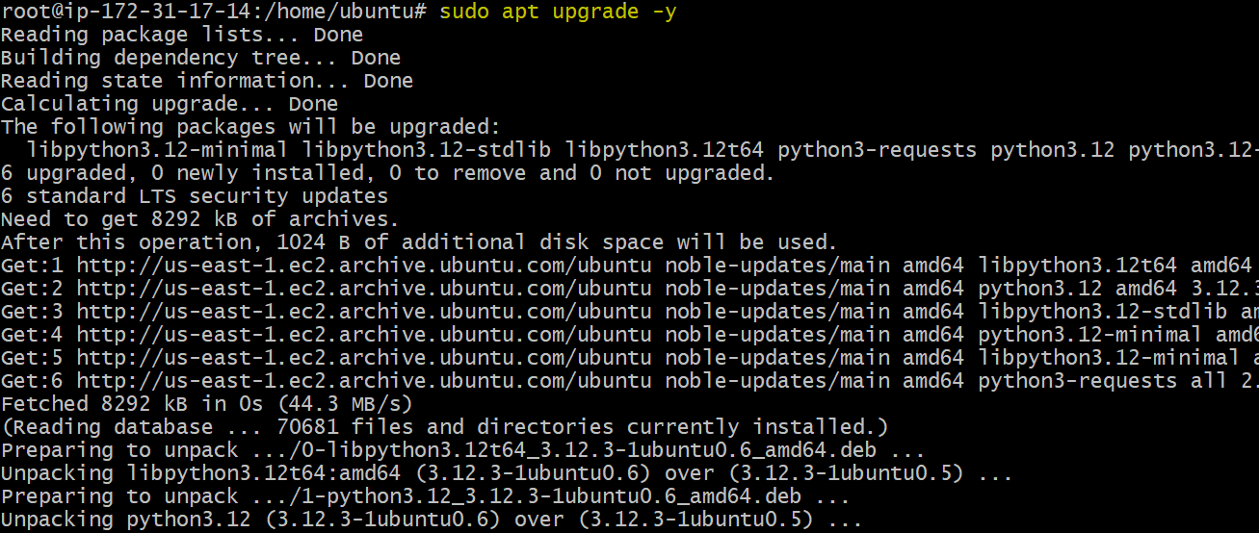

Step 2: Install Required Dependencies
sudo apt install -y software-properties-common
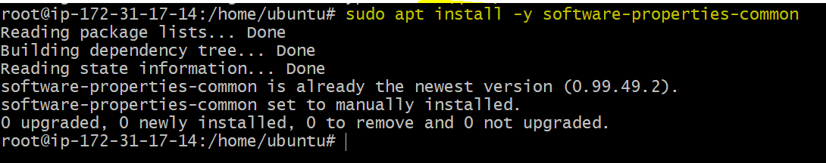

Step 3: Add Ansible PPA (Official)
sudo add-apt-repository --yes --update ppa:ansible/ansible
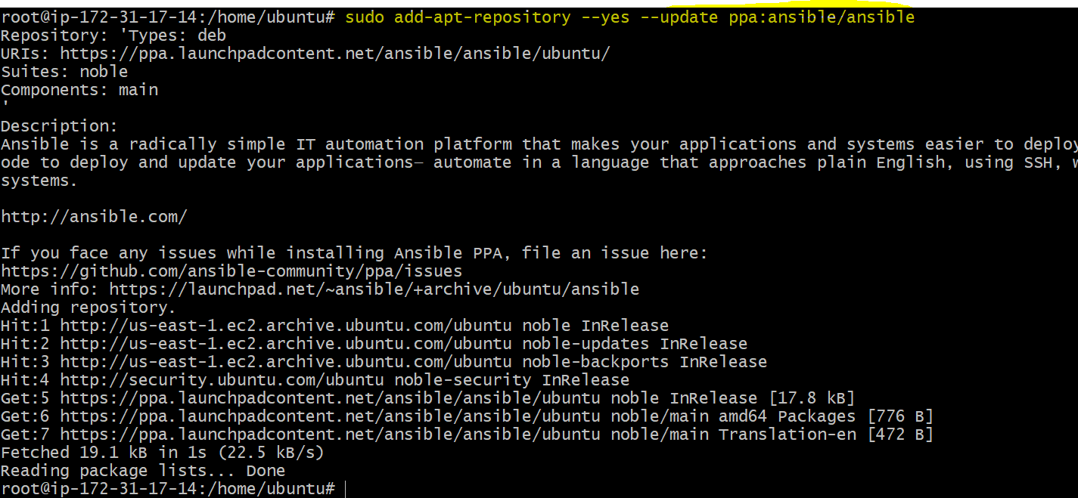

Step 4: Install Ansible
sudo apt install -y ansible
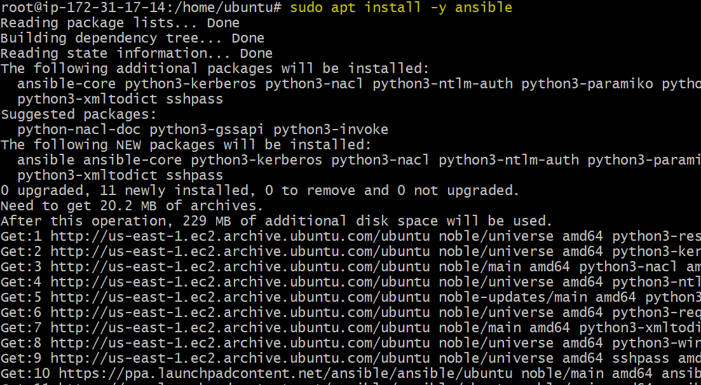

Step 5: Verify Ansible Installation
ansible --version
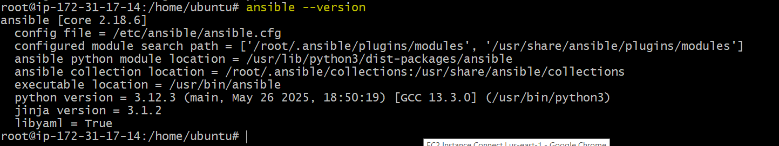

Optional: Set Up Ansible Inventory File
Edit hosts file:
sudo vi /etc/ansible/hosts
Add: (currently public ips added, private ips needs to be added. Public ip changes after every restart.)
[all]
54.225.10.218
54.242.196.231

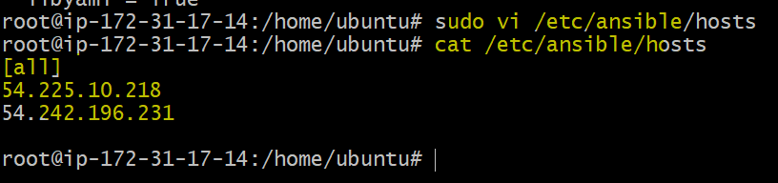

Create ssh password less Authentication between Controller and worker servers.

Using ssh -keygen command create public key in the Ansible controller.
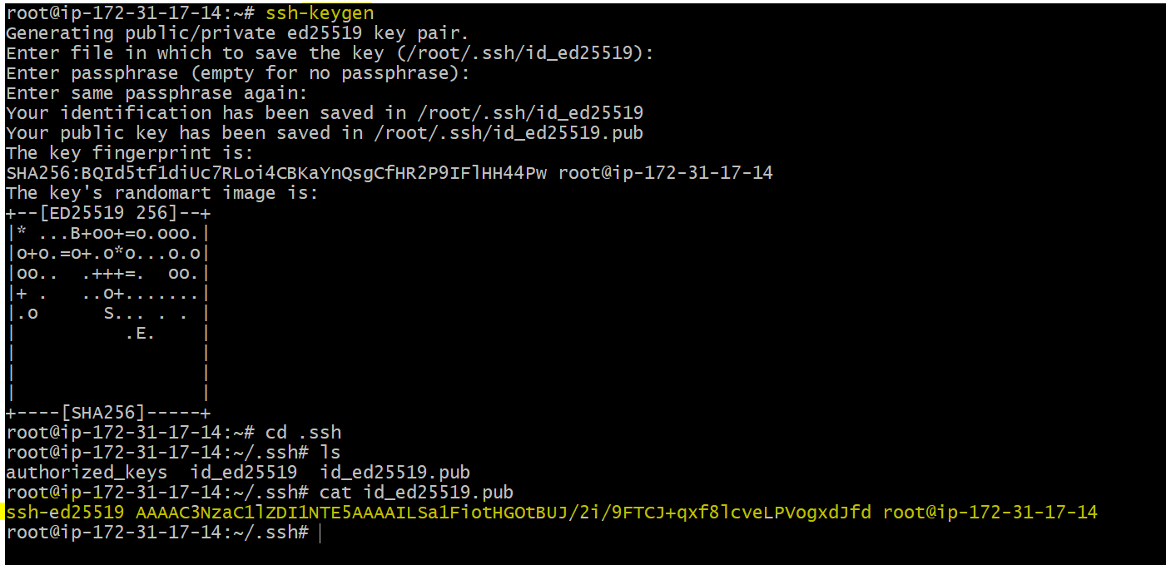

Paste this public key in .ssh > authorized_keys of root user in worker 1 and worker 2.

Worker – 01:
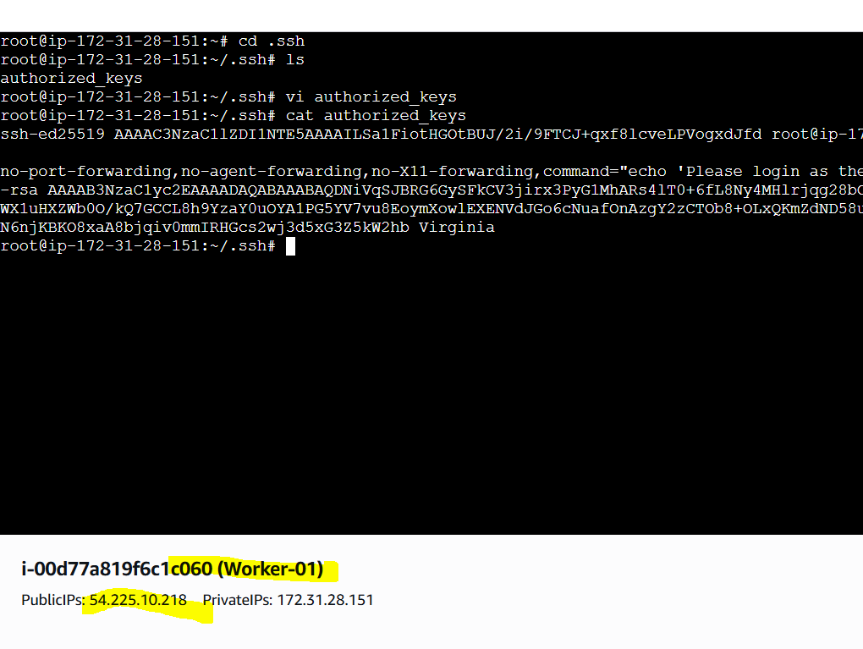

Worker – 02:
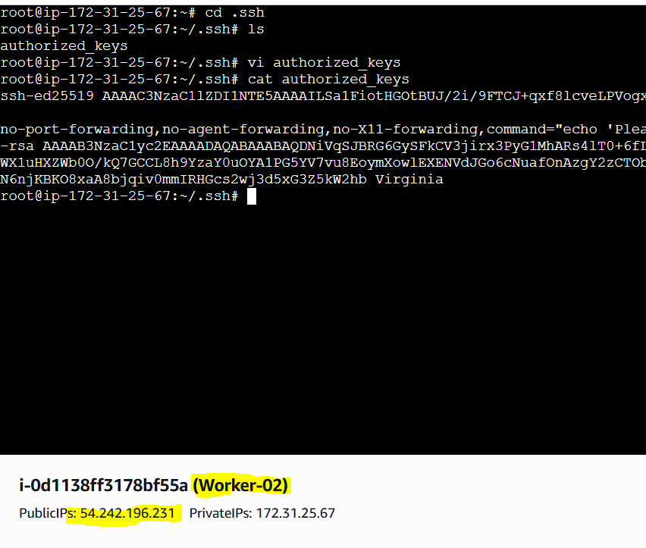

By using command ansible all -m ping we can check setup.
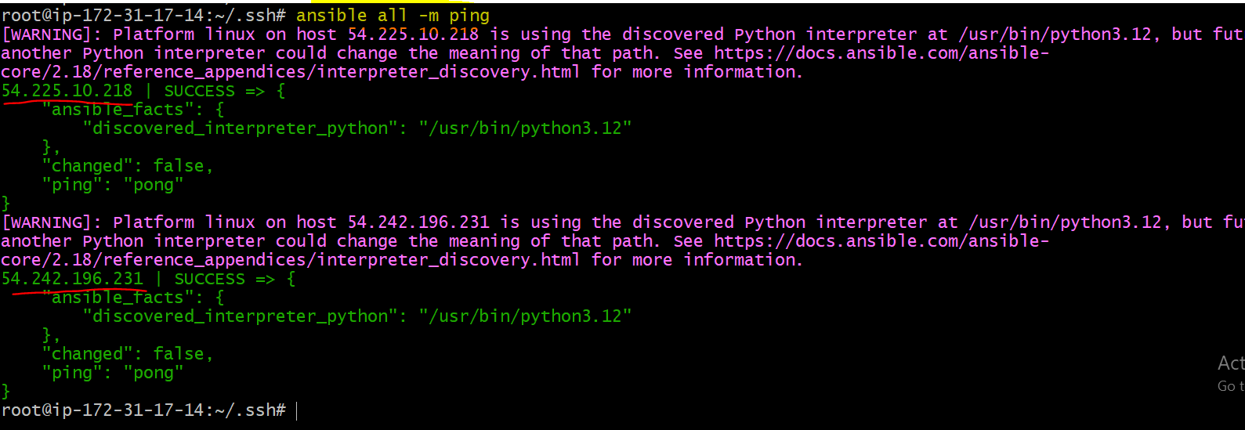

Setup is completed successfully.

3) Execute the adhoc command shared in #dvps-cloud-documents-12 Channel.

# To check the connetivity between slaves
ansible all -m ping


# How to gather facts of slave machine
ansible all -m setup
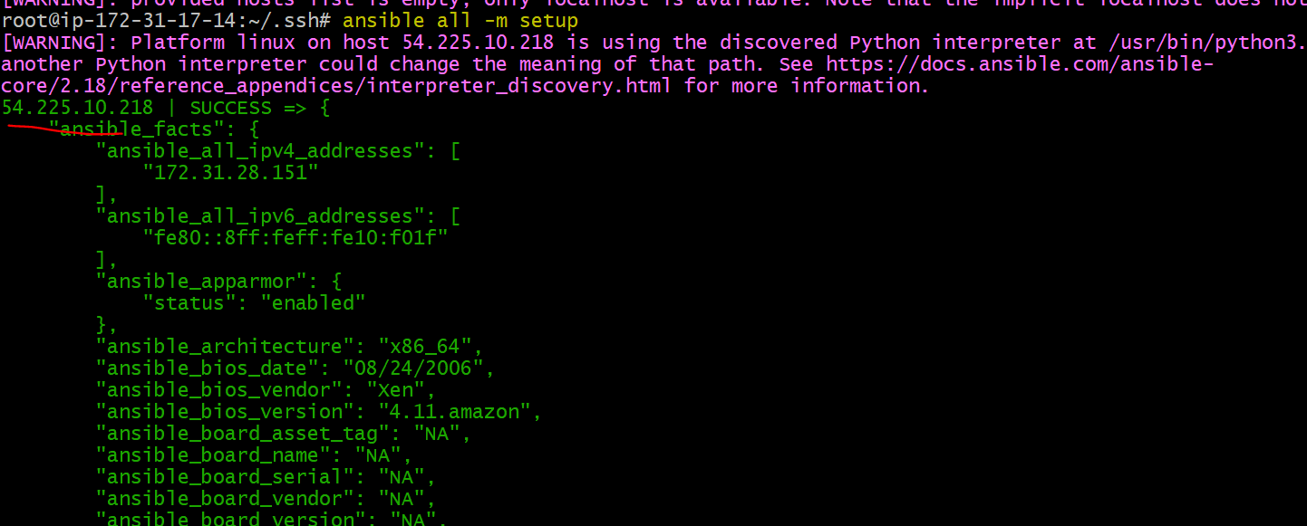

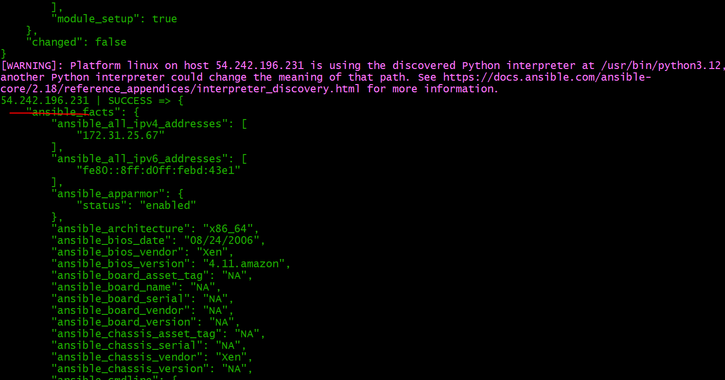

# What if you do not have SSH key-based? How to pass username and password?
ansible all -m ping --user=root --ask-pass
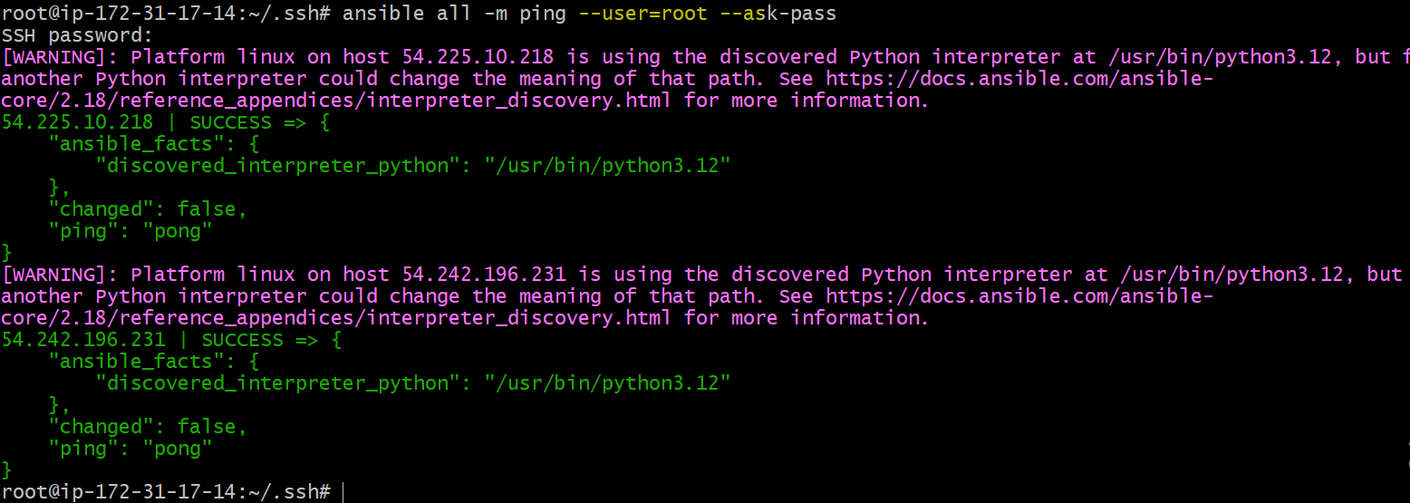

# TO checkthe uptime of a slave machine
ansible all -a uptime
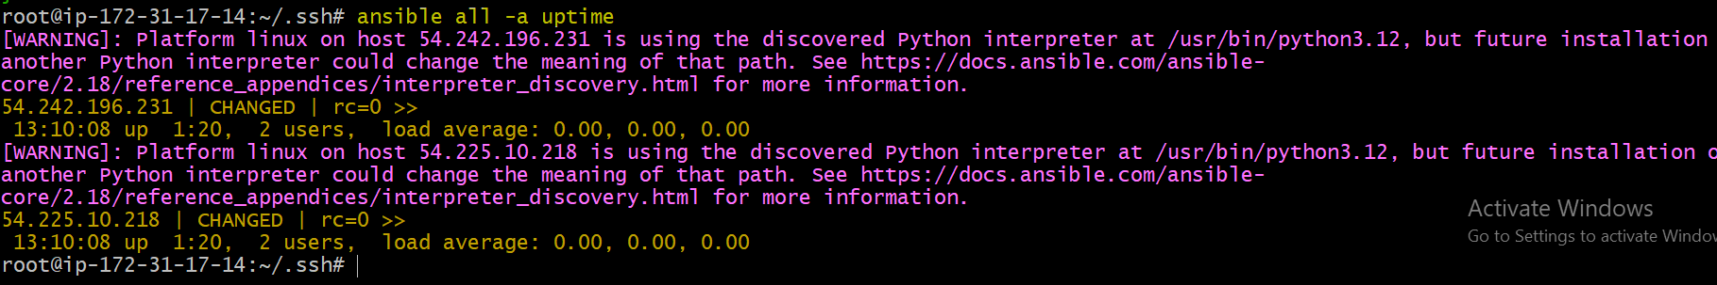

# Tips: -m is the module and -a should contain the command it should run which goes as an argument to command and shell.

# check the free memory or memory usage of host
ansible all -a "free -m"
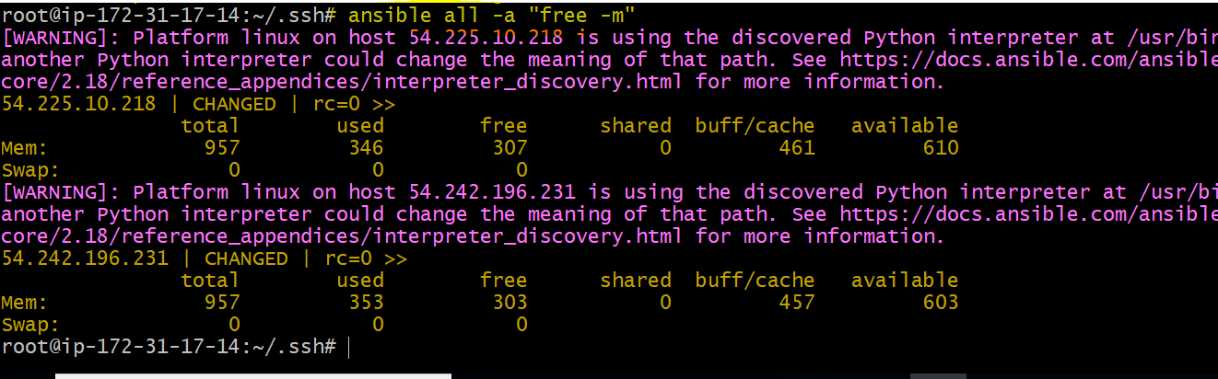

# Execute a command as root user (sudo) on host
ansible all -m shell -a "cat /etc/passwd|grep -i root" -s --ask-sudo-pass
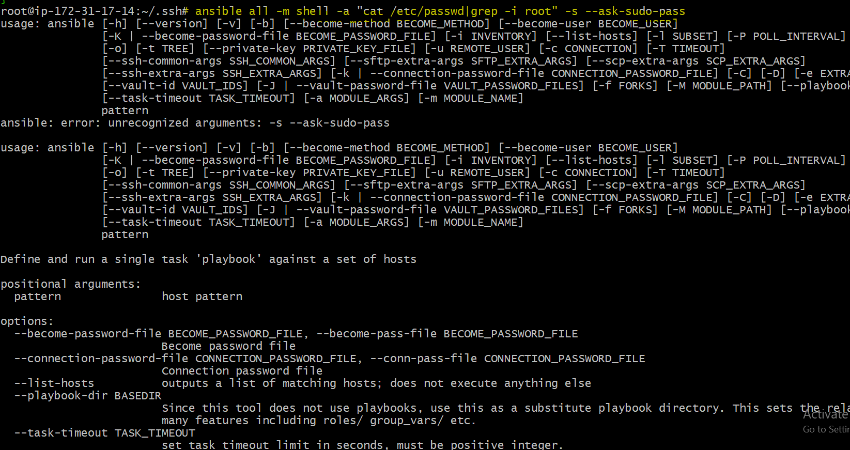

# Execute a command using become module
ansible all -m shell -a "cat /etc/passwd|grep -i root" -b -K

# Tips: -b is the option for become and by default it will become root user
–K is to tell ansible to ask for SUDO password
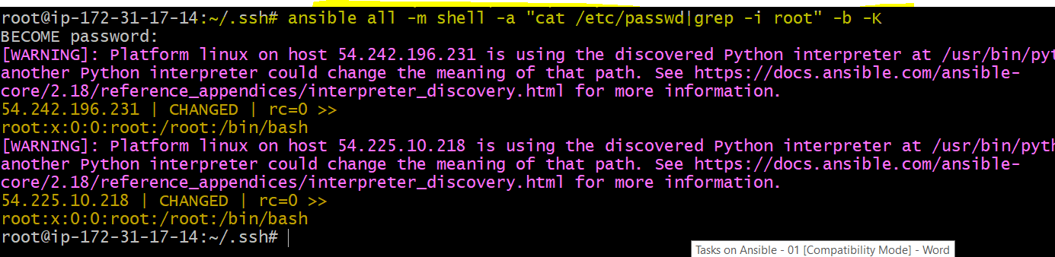

#Execute a command as a different user (sudo su)
ansible all -m file -a "path=/home/ubuntu/test state=directory mode=0755" -b --become-user=ubuntu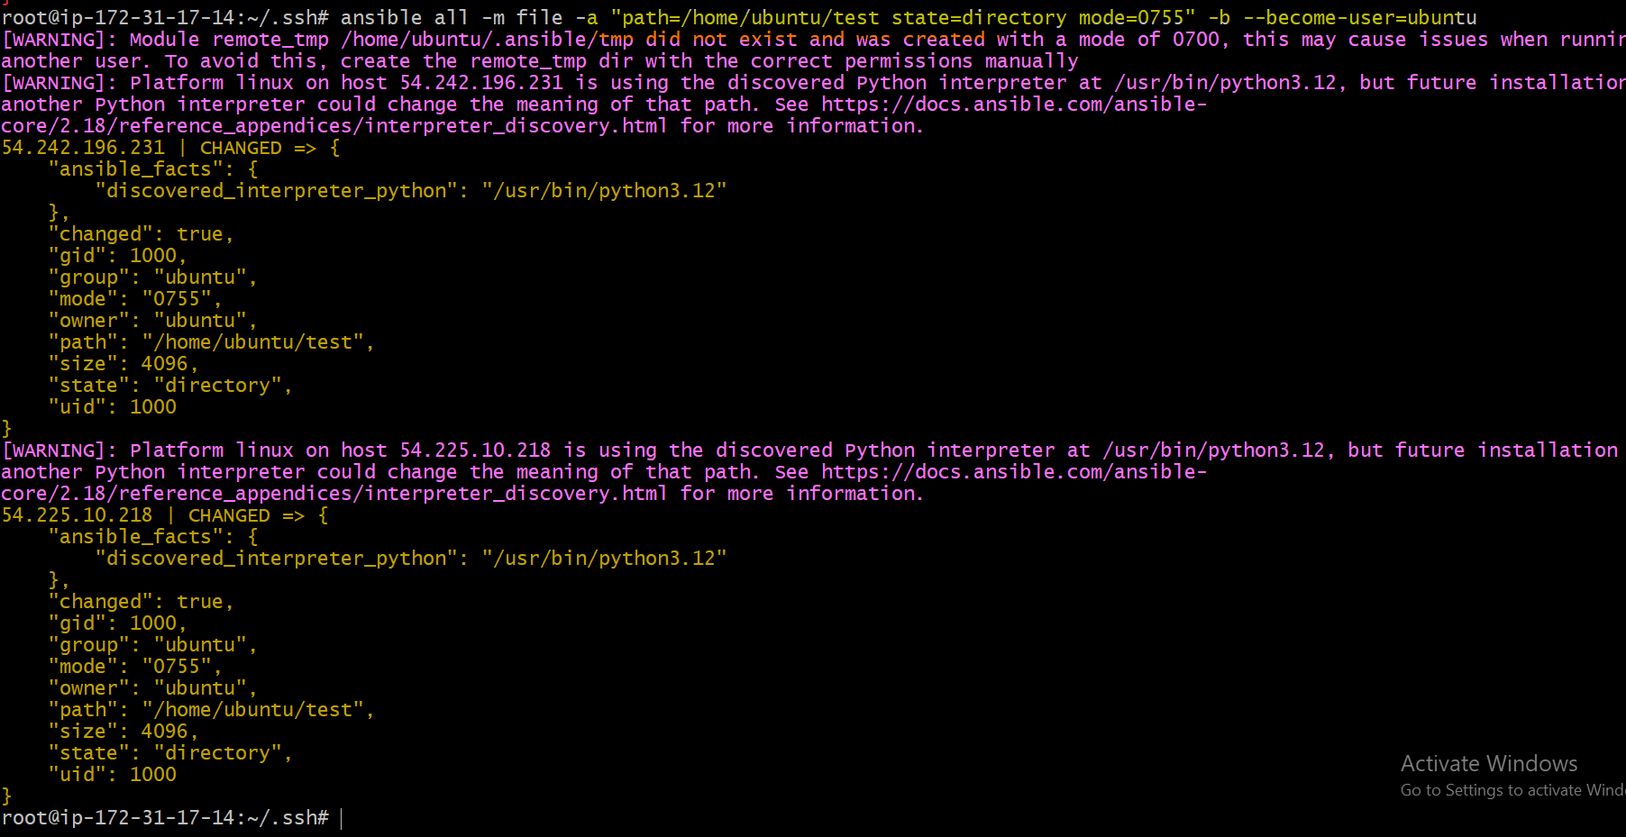

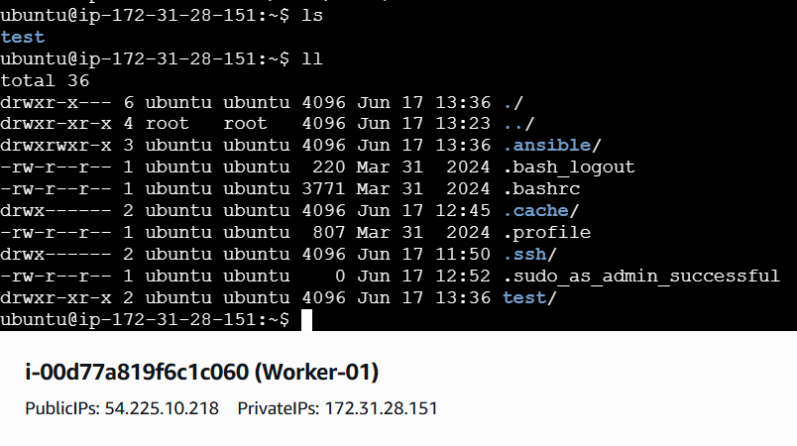
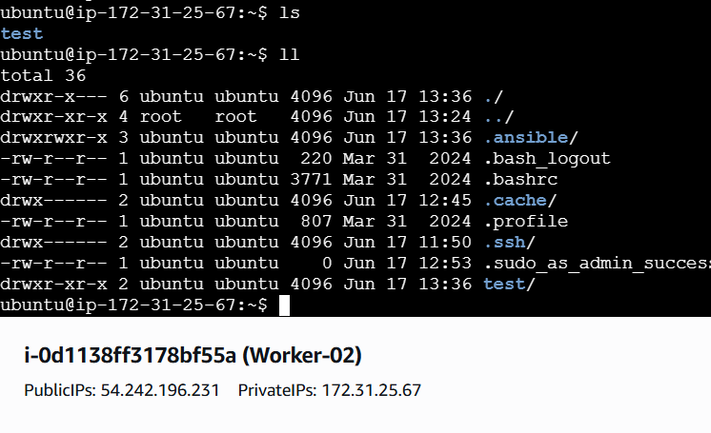

# Create a Linux user group
ansible all -s -m group -a "name=test state=present" -b -K
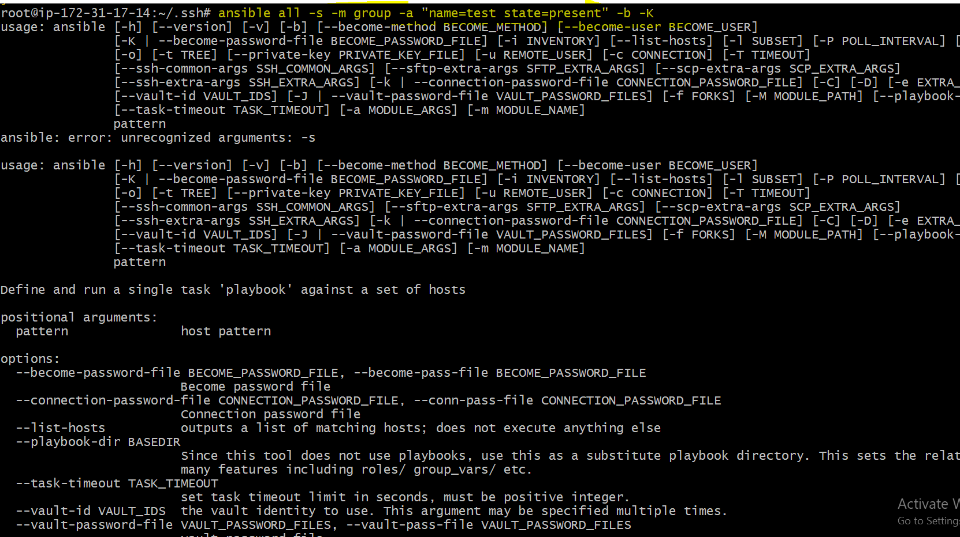

# Create a file with 755 permission
ansible all -m file -a "path=/home/ubuntu/testfile state=touch mode=0755"
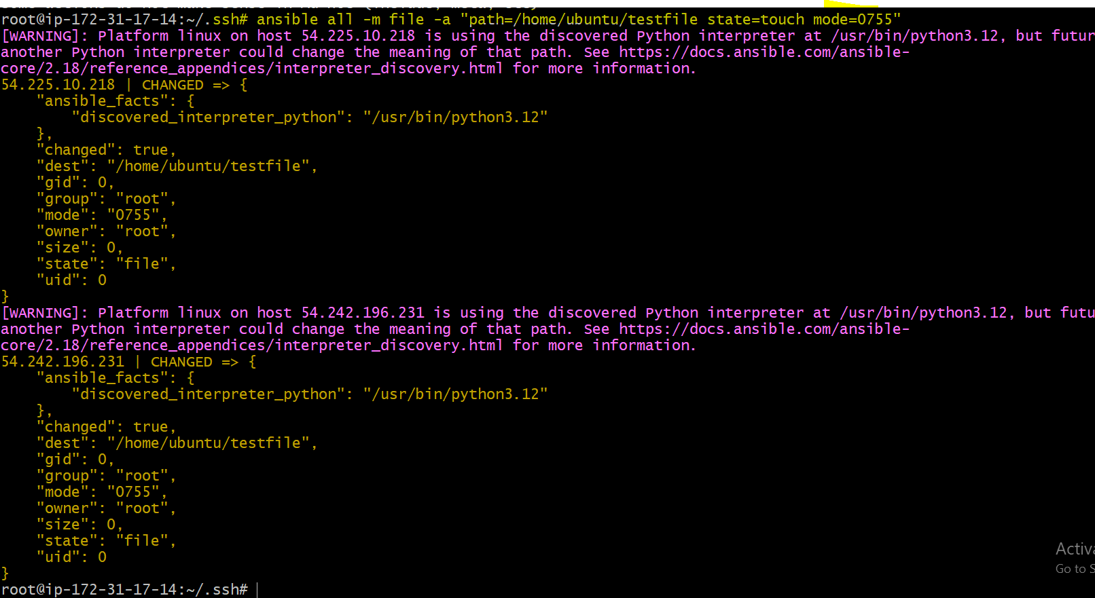
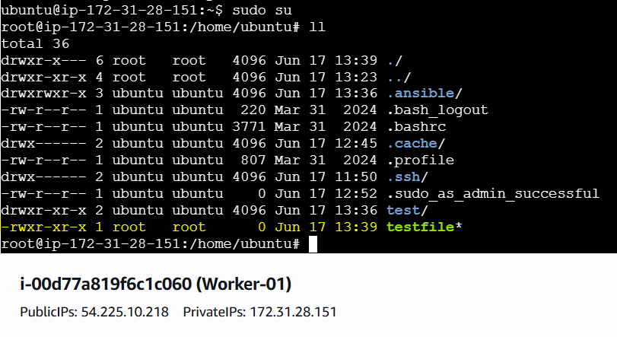
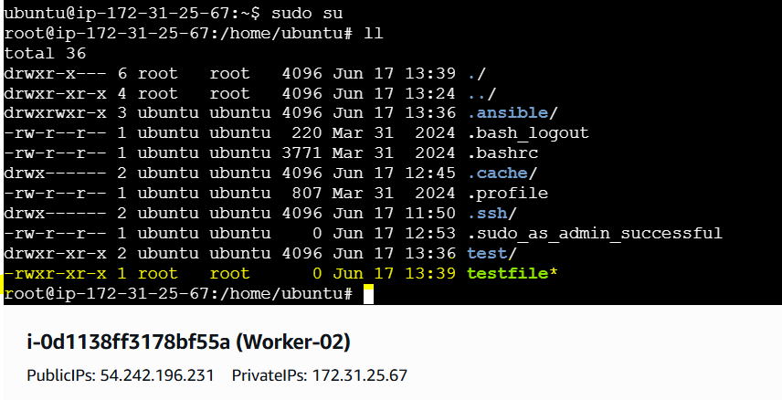

# Change ownership of a file
ansible all -m file -a "path=/home/ubuntu group=root owner=root" -b
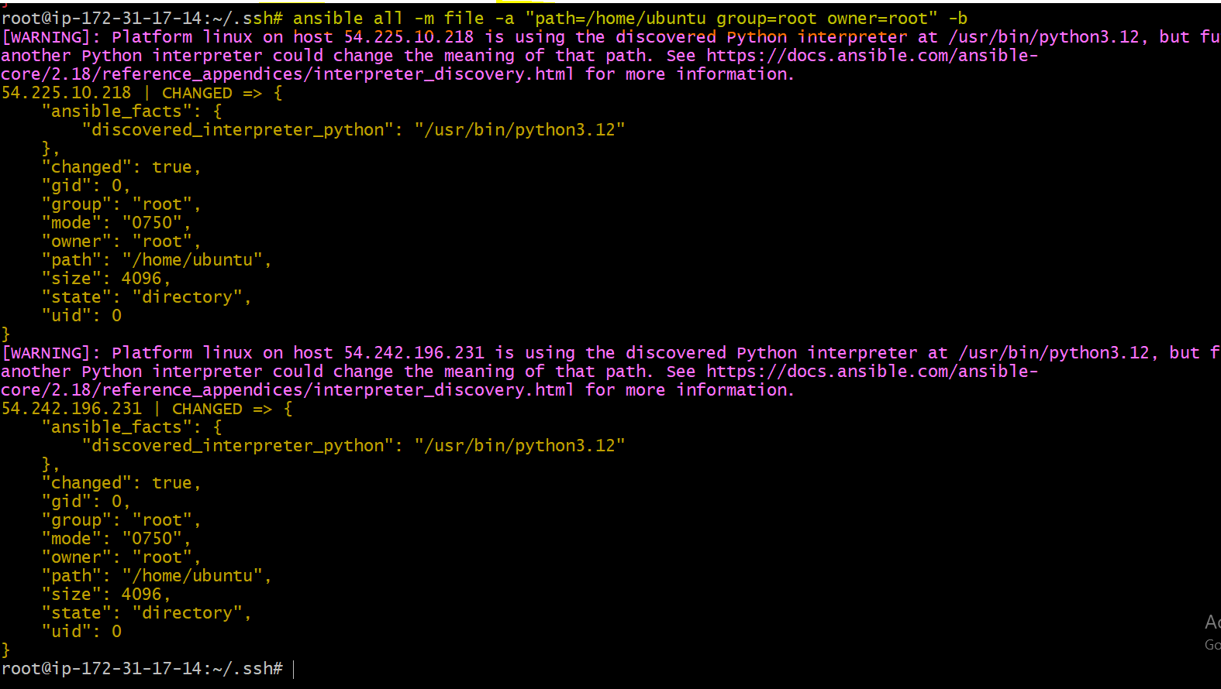



# Install a package using apt command
ansible all -m apt -a "name=apache2 state=present update_cache=yes"
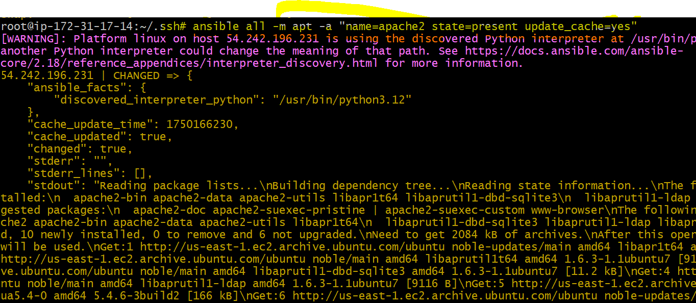
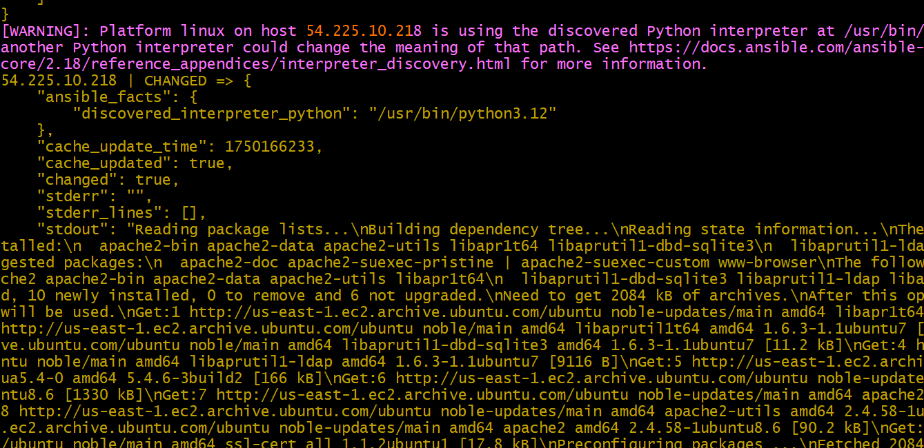
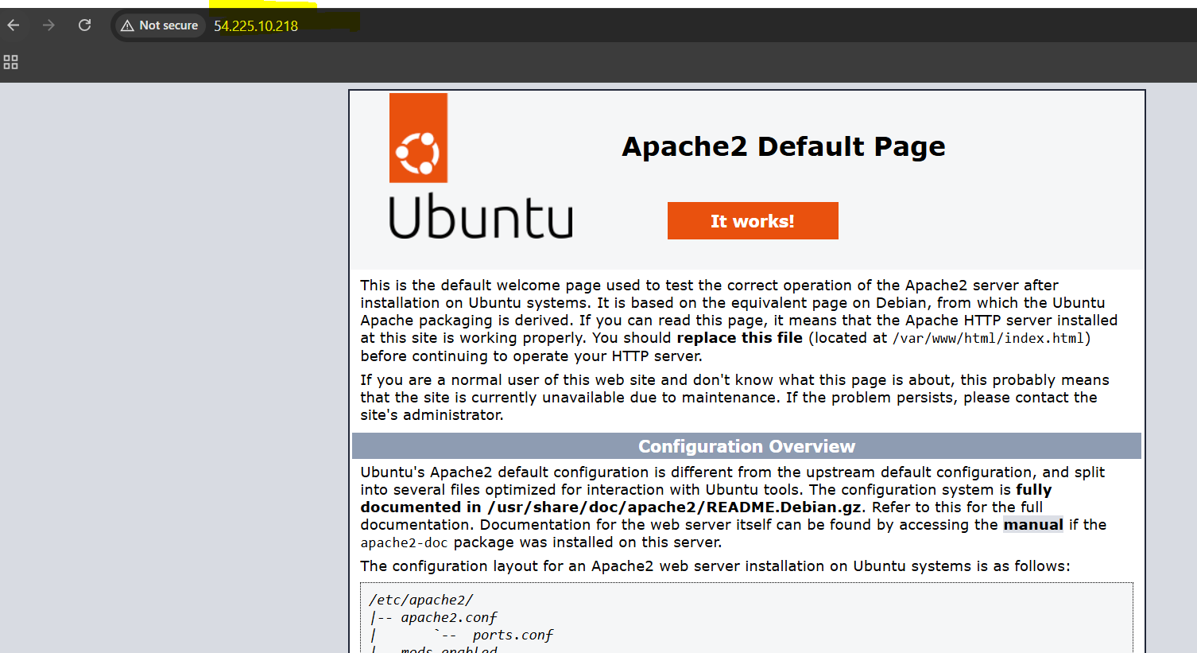
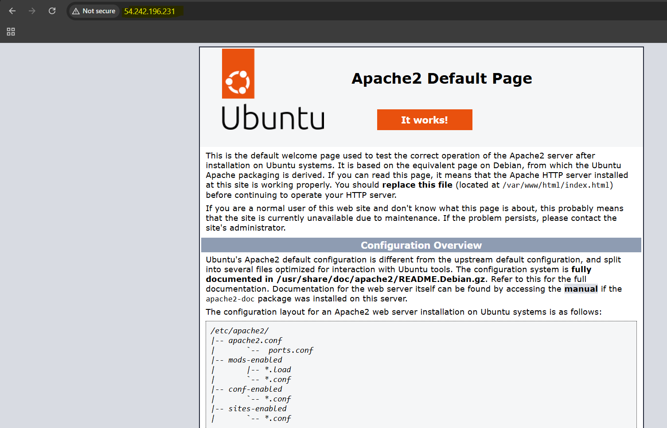

# Start or stop the service

# To Stop
ansible all -m service -a "name=apache2 state=stopped enabled=yes"
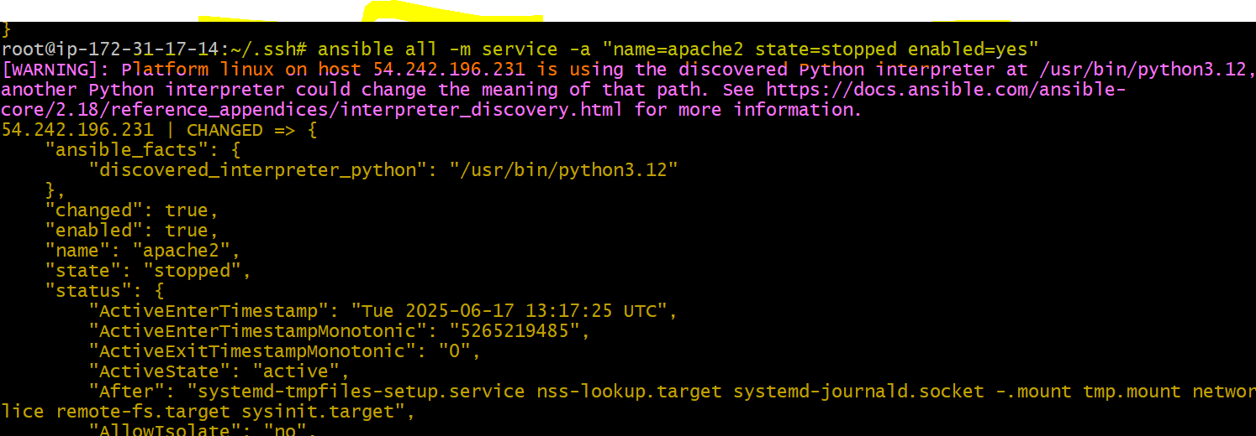
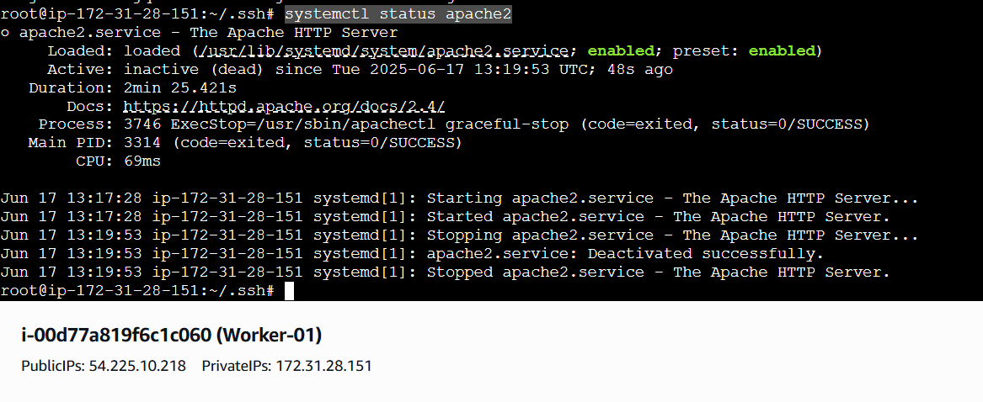
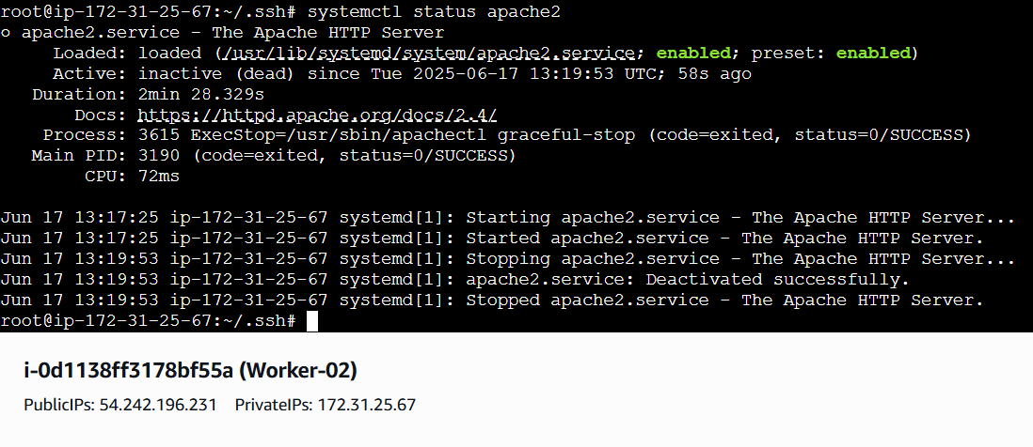

# To Start
ansible all -m service -a "name=apache2 state=started enabled=yes"
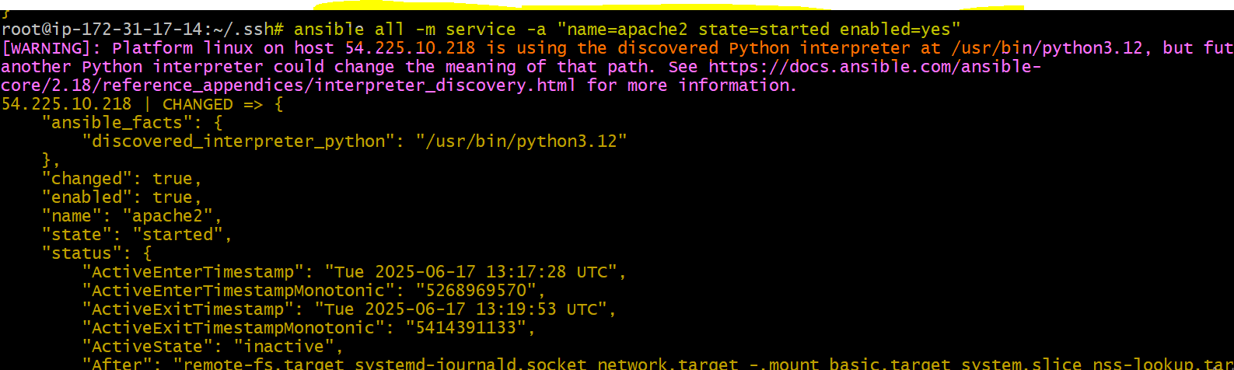
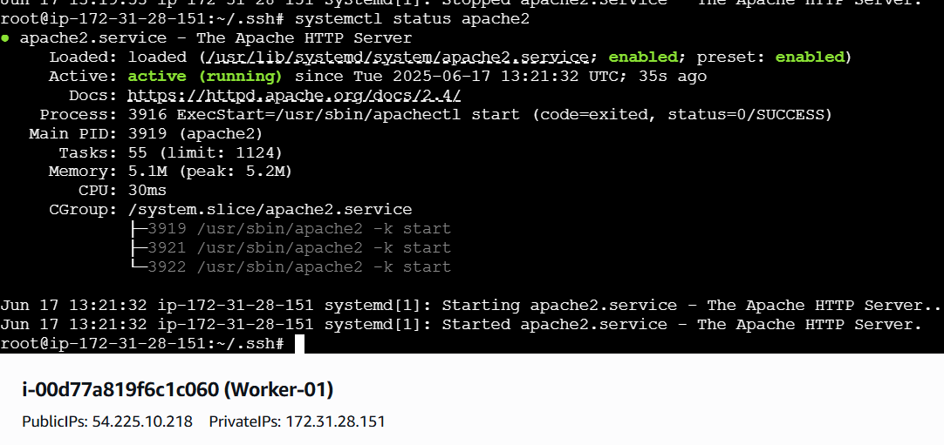
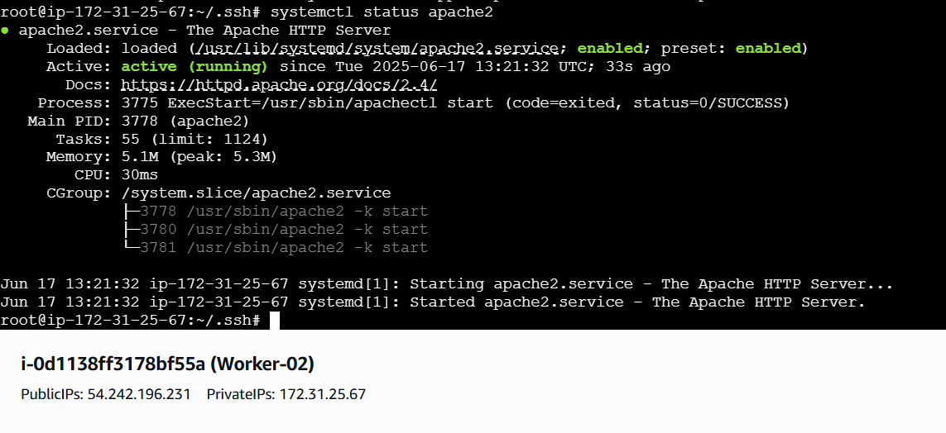

THE-END

